Pauwels Travel Bureau Ltd.
15 Egerton Street, Brantford, Ont. N3T 4L4
Tel. 519-753-2695 / 519-756-4900 - Fax 519-756-6376
tours@pauwelstravel.com – www.pauwelstravel.com

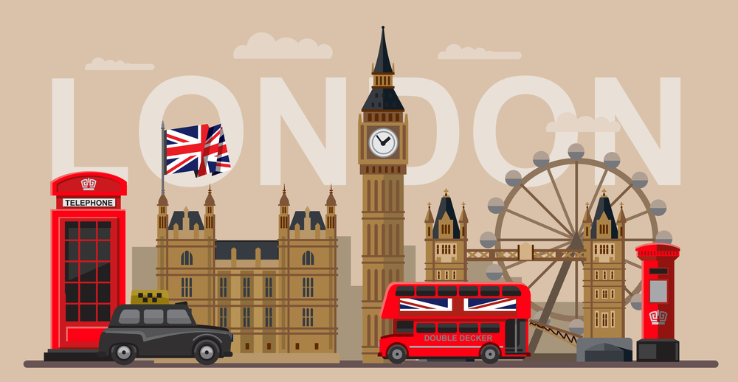

"London in Depth”

10 days, Friday, September 11, to Saturday, September 20, 2026

London is a city where you can find anything you desire, from historical treasures and cultural gems to lively entertainment and fabulous shopping. Join Steve and Sandra for an “In Depth” adventure in the English capital, where you will experience the best of the culture, royalty, and history. Savour the traditional delights of crumpets and scones, crowns and sceptres, teatime and happy hour. Or indulge in the modern pleasures of retail therapy and nightlife. Whatever your preference, you will fall in love with this city.

Tour cost Land Only, based on double occupancy: $4,995.00 - Single room supplement: $975.00

PROPOSED ITINERARY:

Day 1 – Friday, September 11: Windsor Castle
Morning arrival in London. We will meet at the airport for an immediate transfer to Windsor, a historic town in Berkshire, England, famous for being the site of Windsor Castle, the oldest and largest occupied castle in the world. Windsor Castle was built by William the Conqueror in the 11th century, and has been the home of 40 monarchs since then. Lunch at a local restaurant followed by a visit of the castle where you will have an opportunity to admire the magnificent State Apartments, the priceless art collection, the stunning St. George’s Chapel, and the iconic Round Tower. Continue to London and our home for the next nine nights, The Hyde Park International Hotel or similar, located in the Bayswater area. Check in followed by a welcome pint and traditional pub dinner before turning in for the evening.

A WORD ABOUT OUR HOTEL
Nestled on a quiet street just moments from Bayswater and Queensway stations, Hyde Park International offers a comfortable and convenient base for our stay in London. The hotel sits in one of the city’s most walkable neighbourhoods, with cafés, pubs, and restaurants right on the doorstep and Hyde Park only a short stroll away. Rooms are compact but thoughtfully arranged, and the friendly staff help create a welcoming atmosphere after a day of exploring. It’s an ideal location for easy transport connections and relaxed evenings close to home.

Day 2 - Saturday, September 12: Highlights of Central London
Breakfast at the hotel before meeting our local guide for a walking tour of central London. Sights to include; the Tower Bridge, St Paul’s Cathedral, the London Eye, The West End Theatre district, Covent Garden etc. The tour will end in the area of Trafalgar Square. Free time for a late lunch followed by a visit to the National Gallery, housing one of the greatest collection of paintings in the world. Following the visit, we continue to the Embankment where we will find a collection of pubs calling us in for a drink before heading back to the hotel. Traditional English dinner tonight in one of London’s many fine restaurants.
Today you will also receive your 7-Day London Travel Pass which is good for zones 1 & 2 on the London Underground & Buses

Day 3 - Sunday, September 13: Royal Britain
Today we embark on a regal journey through London’s historic heart, where the echoes of monarchy whisper through the ages. Your Royal tour begins with majestic Buckingham Palace, the late Queen’s opulent residence, with its grand State Rooms revealing centuries of tradition. Stroll through the verdant Green Park, witness the precision of the Changing of the Guard, and marvel at the storied Westminster Abbey. As Big Ben chimes, feel the pulse of British sovereignty that has shaped the world. This tour is a tapestry of royal heritage, woven into the very fabric of the city. After time for lunch our visits for today will end where they began - at Buckingham Palace where you will have a timed entry to visit the interior. With no group dinner tonight perhaps a show or concert would be a great way to end the day.

Day 4 - Monday, September 14: London at War
Discover London’s wartime history with a tour that takes you back to the days of WWII. This morning we head to the Imperial War Museum. The IWM London is the world's leading museum of war. Founded during the First World War, it gives voice to the extraordinary experiences of ordinary people forced to live their lives in a world torn apart by conflict. Displayed across six floors, the museum's vast collections encompass a wealth of objects - from uniforms to photographs, vehicles to films, weapons to works of art - each with a story to tell. Following our visit, we make our way back to central London where, after time for lunch, we are joined by our guide for a visit to the Churchill War Rooms, where strategies were forged, and walk the streets that survived the Blitz. See the Cenotaph, honoring the fallen, and explore the remnants of bomb shelters. This tour is a poignant reminder of the resilience and courage of London during one of its darkest times.

Day 5 - Tuesday, September 15: London Through the Ages
Today we embark on a captivating journey through London’s storied past with a “London Through the Ages” tour. This immersive experience will guide you from the Roman establishment of Londinium to the bustling modern metropolis it is today. You’ll explore landmarks that tell tales of the city’s Roman roots, medieval might, and its evolution through the Tudor, Stuart, and Victorian eras, all the way to contemporary times. Highlights include the ancient Roman Wall and the architectural marvels that line the Thames. This tour is a splendid tapestry of history, perfect for those with a passion for the past and a desire to see how it has shaped the London we know today. Following time for lunch we head to The British Museum famous for its amazing collection of rare and historic artefacts from around the world. Highlights include the Rosetta Stone, Parthenon sculptures and Egyptian mummies. No group dinner this evening.

Day 6 – Wednesday, September 16: London Food Tour
Savor the flavors of London on a food tour that culminates in the historic Borough Market. Begin with a tasting of artisanal British cheeses, followed by a stroll through the vibrant stalls offering everything from fresh produce to gourmet delicacies. At Borough Market, indulge in traditional fish and chips, sample a variety of international cuisines, and end your journey with a sweet treat from a local bakery. This tour is a feast for the senses, showcasing the best of London’s culinary diversity. This afternoon is free for individual activities.

Day 7 - Thursday, September 17: London Rocks
London’s music scene is a dynamic tapestry of history and innovation, offering a rich array of experiences for every music enthusiast. From the legendary Abbey Road Studios, immortalized by The Beatles, to the contemporary beats echoing through the O2 Arena, a music tour in London is a journey through the very soul of the city. This morning we will discover the bohemian charms of some of London’s most vibrant neighborhoods by visiting sites associated with bands like The Beatles and Pink Floyd as well as some film sites. Afternoon and evening free.

Day 8 - Friday, September 18: Greenwich
Breakfast before making the short trip to Greenwich where royal history and maritime heritage blend seamlessly. We begin at Greenwich Park offering spectacular views of Canary Wharf and the City of London. Next will be a visit to the Royal Observatory and an opportunity to stand on the Prime Meridian. We round out the morning sights with a visit to Greenwich Market where you will have an opportunity to enjoy lunch before returning to Central London. Naval enthusiasts may want remain in Greenwich to visit the Cutty Sark and National Maritime Museum, reportedly the largest maritime museum in the world.

Day 9 – Saturday, September 19: Personal choices
Today is your last day in London so we have left it free for last minute sightseeing or souvenir shopping. This may be an ideal time to visit some of the sites just outside London such as Stonehenge or Bath, perhaps a Downton Abbey tour including a visit to Highclere Castle. You may opt for a cruise on the Thames River that ends at Hampton Court, home of Henry the VIII, visit some of the markets we have not yet visited, take in a West End show or perhaps attend a Premiership football match at one of the local grounds. Farewell dinner this evening.

Day 10 - Sunday, September 20:
Breakfast at the hotel followed by transfer to London, Heathrow airport for your return flight to Toronto.

Land Only cost, based on double occupancy: $4,995.00 - Single room supplement: $975.00

**Please note that the schedules for a number of the activities we have planned are not yet available. The order of the sightseeing may have to be adjusted as a result

Included in the tour price are
- 9 nights accommodation at the Hyde Park International Hotel or similar, based on superior double occupancy – the single (executive) room supplement is $975.00
- Breakfast daily and a total of 3 dinners and one lunch;
- All transfers, sightseeing, and excursions as described in the itinerary;
- 7- Day London travel pass which includes unlimited travel on the underground & London buses in zone 1 & 2
- Services of a tour concierge;
- Gratuities to local guides and drivers.

Not included are:
- Airfare;
- All items of a personal nature;
- Wine, beer, mineral water and similar beverages with dinners;
- Travel insurance, available on request.

